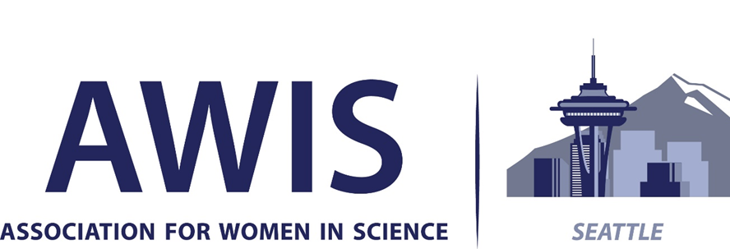

**2024 Seattle AWIS Awards**

We are accepting nominations for the 2024 AWIS Awards honoring women in three categories:

This nomination form is available online at <https://seattleawis.org/awards/>

***- Science or Technology Advancement and Leadership* -**

***- Early Career Achievement in STEM -***

***- Excellence in STEM Education/Outreach -***

* One winner in each of these categories will be chosen by the Awards Committee after evaluation of all submitted nominations and approval by the Seattle AWIS Board.
* Presentation of the awards will take place on June 18, 2024, at the Seattle AWIS Banquet.
* Nominations must be sent to [**awards@seattleawis.org**](mailto:awards@seattleawis.org) by **Friday,** **January 5, 2024, 6 PM**.

**Criteria**

* Award nominees must be geographically located within Washington State.
* Nominee should have fostered the development of other women in science.

**Award for Science or Technology Advancement and Leadership**

A woman in science, technology, engineering, or math (STEM) working in academia, a non-profit organization, industry or government whose innovative ideas have contributed to scientific or technological advances and whose leadership has been demonstrated in her work and in the community.

**Award for Early Career Achievement in STEM**

A woman who has excelled in her chosen field for 8 years or less (after degree) in an academic, non-profit, industry or government setting, and shows exceptional potential for leadership and innovation in her field.

**Award for Excellence in STEM Education/Outreach**

A woman who has demonstrated innovative and sustained contribution to education in the field of science, technology, engineering or math (STEM). This may include contributions to outreach activities or programs that promote STEM or encourage women in science or whose work has influenced the public, especially women, of any age or career level.

* *\*AWIS membership is* ***not*** *required for nominee or nominator* of the awards.
* Self-nominations are welcomed.
* Award winners will give a short presentation at the banquet on Tuesday, June 18, 2024.

**Easy Nomination Process** There are two parts to the nomination:

1. Completion of the nomination form with contact details and nominator’s statements of support

The nomination form is available at <https://seattleawis.org/awards/>

1. Nominee’s resume or CV (preferred) or PDF of LinkedIn profile (accepted), highlighting outreach, mentoring activities, and awards in addition to education and career path.

Complete nominations - nomination form plus resume/CV/Linked In profile - must be received at

[**awards@seattleawis.org**](mailto:awards@seattleawis.org) by **Friday,** **January 5, 2024, 6 PM**.

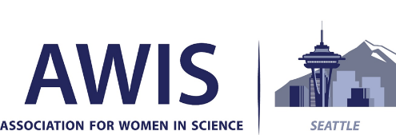

**Nomination Form**

**2024 Seattle AWIS Awards for**

***Science or Technology Advancement & Leadership***

***Early Career Achievement in STEM* and**

***Excellence in STEM Education/Outreach***

Award winners will be honored at a June 18, 2024, banquet.

**Category of Nomination:**

___ **Science or Technology Advancement and Leadership**

1. A woman in science, technology, engineering, or math (STEM) working in academia, a non-profit organization, industry or government whose innovative ideas have contributed to scientific or technological advances and whose leadership has been demonstrated in her work and in the community.
2. A woman who has fostered the development of other women in science.

___ **Early Career Achievement in STEM**

1. A woman who has excelled in her chosen field for 8 years or less (after degree) in an academic, non-profit, industry or government setting, and shows exceptional potential for leadership and innovation in her field.
2. A woman who has fostered the development of other women in science.

___ **Excellence in STEM Education/Outreach**

1. A woman who has demonstrated innovative and sustained contribution to education in the field of science, technology, engineering, or math (STEM). This may include contributions to outreach activities or programs that promote STEM or encourage women in science or whose work has influenced the public, especially women, of any age or career level.
2. A woman who has fostered the development of other women in science.

**Nominee Information** (Self-nominations are welcomed.)

Name: Degree(s):

Employer: Job Title:

Email: Phone:

**Nominator Information**

Name: Degree(s):

Employer: Job Title:

Email: Phone:

Nominator: Please answer the following questions.

1. **What is your relationship to the nominee? How do you know them and their work? (maximum 250 words)**
2. **From your experience, what specific attributes or contributions make your nominee the ideal award recipient? Describing specific instances or personal experiences/anecdotes will provide the most insight for judges. (maximum 600 words)**
3. **Can you describe any special contributions this woman has made to foster the development of other women in science? (maximum 400 words)**
4. **Please submit the nominee’s resume/CV/PDF of LinkedIn profile** **to** [**awards@seattleawis.org**](mailto:awards@seattleawis.org)

The resume/CV/LinkedIn profile should highlight outreach, mentoring activities, awards, in addition to education & career path.

Complete nominations (nomination form and resume/CV/PDF of LinkedIn profile) must be received at

[**awards@seattleawis.org**](mailto:awards@seattleawis.org) by **Friday,** **January 5, 2024, 6 PM.**

Award winners will be asked to give a short presentation at the June 18, 2024, banquet.