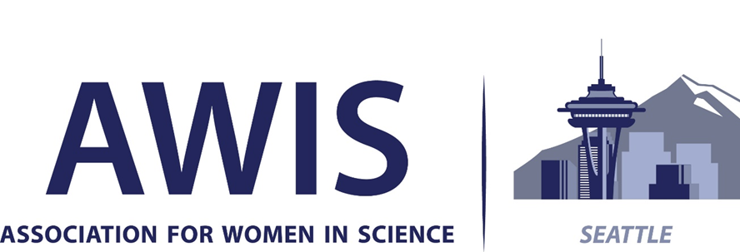

2026 Seattle AWIS Awards
We are accepting nominations for the 2026 AWIS Awards honoring women in three categories:
This nomination form is available online at https://seattleawis.org/awards/

- Science or Technology Advancement and Leadership -
- Early Career Achievement in STEM -
- Excellence in STEM Education or Outreach -

- One winner in each of these categories will be chosen by the Awards Selection Committee after evaluation of all submitted nominations.
- Presentation of the awards will take place on June 16, 2026, at the Seattle AWIS Banquet.
- Nominations must be received at awards@seattleawis.org by Monday, Jan. 12, 2026, midnight.

Criteria:
► Award nominees must be geographically located within Washington State.
► Nominee should have fostered the development of other women in science

Award for Science or Technology Advancement and Leadership
A woman in science, technology, engineering, or math (STEM) working in academia, a non-profit organization, industry or government whose innovative ideas have contributed to scientific or technological advances and whose leadership has been demonstrated in her work and in the community.

Award for Early Career Achievement in STEM
A woman who has excelled in her chosen field for 8 years or less after receiving her major degree (e.g. MS, PhD, MD) in an academic, non-profit, industry or government setting, and shows exceptional potential for leadership and innovation in her field.

Award for Excellence in STEM Education or Outreach
A woman who has demonstrated innovative and sustained contribution to education in the field of science, technology, engineering or math (STEM). This may include contributions to public health, outreach activities or programs that promote STEM or encourage women in science or whose work has influenced the public, especially women, of any age or career level.

► *AWIS membership is not required for nominee or nominator of the awards.
► Self-nominations are welcomed.
► Award winners are expected to give a short presentation at the banquet on Tuesday, June 16, 2026.

Easy Nomination Process There are two parts to the nomination:
- Completion of the nomination form with contact details and nominator’s statements of support
The nomination form is available at https://seattleawis.org/awards/
- Nominee’s resume or CV (preferred) or PDF of LinkedIn profile (accepted), highlighting outreach, mentoring activities, and awards in addition to education and career path.

Complete nominations - nomination form plus resume/CV/Linked In profile - must be received at
awards@seattleawis.org by Monday, January 12, 2026, midnight.
.

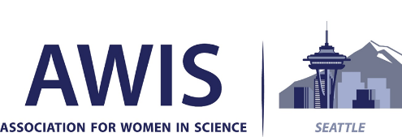

2026 Seattle AWIS Awards for
Science or Technology Advancement & Leadership
Early Career Achievement in STEM and
Excellence in STEM Education or Outreach
Award winners will be honored at a June 16, 2026, banquet.

Category of Nomination:
___ Science or Technology Advancement and Leadership
- A woman in science, technology, engineering, or math (STEM) working in academia, a non-profit organization, industry or government whose innovative ideas have contributed to scientific or technological advances and whose leadership has been demonstrated in her work and in the community.
- A woman who has fostered the development of other women in science.

___ Early Career Achievement in STEM
- A woman who has excelled in her chosen field for 8 years or less after receiving her major degree (e.g. MS, PhD, MD) in an academic, non-profit, industry or government setting, and shows exceptional potential for leadership and innovation in her field.
- A woman who has fostered the development of other women in science.

___ Excellence in STEM Education or Outreach
- A woman who has demonstrated innovative and sustained contribution to education in the field of science, technology, engineering or math (STEM). This may include contributions to public health, outreach activities or programs that promote STEM or encourage women in science or whose work has influenced the public, especially women, of any age or career level.
- A woman who has fostered the development of other women in science

Nominee Information (Self-nominations are welcomed.)
Name: Degree(s):
Employer: Job Title:
Email: Phone:

Nominator Information
Name: Degree(s):
Employer: Job Title:
Email: Phone:

Nominator: Please answer the following questions.
- What is your relationship to the nominee? How do you know her and her work? (maximum 250 words)

- From your experience, what specific attributes or contributions make your nominee the ideal award recipient? Describing specific instances or personal experiences/anecdotes will provide the most insight for judges. (maximum 600 words)

3. Can you describe any special contributions this woman has made to foster the development of other women in science? (maximum 400 words)

Please submit the nominee’s resume/CV/PDF of LinkedIn profile to awards@seattleawis.org
The resume/CV/LinkedIn profile should highlight outreach, mentoring activities, awards, in addition to education & career path.

Complete nominations (nomination form and resume/CV/PDF of LinkedIn profile) must be received at
awards@seattleawis.org by Monday, January 12, 2026, midnight.

