Seattle AWIS Program: “Lumen Bioscience: Drugs From Algae”
Co-hosted by Seattle AWIS and Lumen Bioscience
Wednesday – May 20, 2026 – 6:00-8:00pm
Hybrid: Fred Hutch Thomas Building and Zoom
Registration: https://seattleawis.org/event/lumen-bioscience-drugs-from-algae/

Lumen Bioscience Speakers

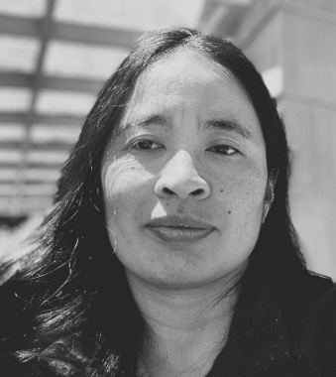
Nhi Khuong, PhD
EVP, Pre-clinical R&D and Chief of Staff

Dr. Khuong is a scientist and strategic leader passionate about translating cutting-edge biology into medicines that reach patients. As EVP of Preclinical Development at Lumen Bioscience, she has spent nearly a decade building and scaling the organization's preclinical function, from the ground up, establishing the teams, systems, and processes that underpin Lumen's novel spirulina-based oral biologics platform.
Nhi has been instrumental in shaping the infrastructure that enables Lumen to move programs efficiently from discovery through candidate selection and into cGMP manufacturing readiness for first-in-human trials, across infectious, inflammatory, and cardiometabolic disease. Her work sits at the intersection of scientific leadership and operational excellence, building not just pipelines, but the platform and organization capable of sustaining them.
Nhi holds a Ph.D. in Molecular Genetics and Cell Biology from the University of Chicago and completed a CDC/APHL Emerging Infectious Diseases Fellowship. She believes the best science happens at the intersection of rigorous discovery, collaboration, and thoughtful leadership.

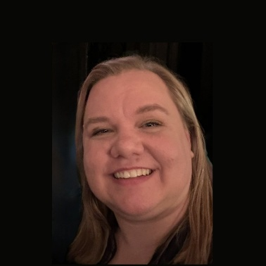
Summer Radler, MS, RAC, ASQ CQA
Sr. Director, Head of Regulatory Affairs

Summer Radler is currently the Sr. Director, Head of Regulatory Affairs at Lumen Bioscience where she leads regulatory strategy for all of their products. Prior to Lumen, she held the position of Director, Regulatory Affairs at Roivant Sciences, where she was the Global Regulatory Lead for a Phase 2 investigational pulmonary hypertension drug. Previously, at Sierra Oncology (acquired by GSK), she led global regulatory submissions for OJJAARA (momelotinib), leading its progression from the initiation of the pivotal Phase 3 study through EU and U.S. marketing applications. Earlier in her career, she held regulatory roles of increasing responsibility at Bio-Rad Laboratories and Endocyte (acquired by Novartis).
She holds an M.S. in Regulatory Affairs from Northeastern University and a B.S. in Animal Science and Biochemistry from Purdue University, and certifications as a Regulatory Affairs Professional (RAC) and Quality Auditor (ASQ CQA).

