Congratulations to the 2026 AWIS Award Recipients
Science Advancement and Leadership: Dr. Joanna Ellington, CEO, Glyciome
Early Career Achievement in STEM Dr. Kim Ingraham, Assistant Professor,
UW Electrical and Computer Engineering
Excellence in STEM Education/Outreach Dr. Nina Salama, Senior VP for Education
Fred Hutch Cancer Center
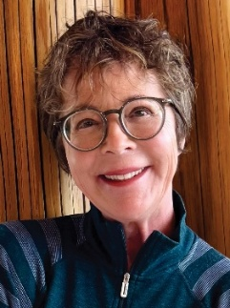
Award for Science Advancement and Leadership
Dr. Joanna Ellington, DVM, PhD;
CEO, Glyciome

Dr. Joanna Ellington is a scientist and inventor whose work has reshaped genital healthcare. With 25 issued patents and 40 years of leadership, she has turned scientific discovery into innovations that changed regulatory and clinical paradigms.
After earning her DVM and becoming one of the first women to practice large-animal medicine in Washington, Dr. Ellington completed her PhD at Cornell University. Her early research helped define modern assisted reproduction culture media. Her NIH-funded research at Washington State University identified defects in human sperm that impact their Fallopian tube storage causing infertility. Her invention of Pre-Seed® Fertility Lubricant resulted in a new FDA medical device category for sperm-safe lubricants and eliminated misleading “non-spermicidal” labeling of products that harmed sperm equivalently to contraceptive gels. This work led to her receiving the International Young Andrologist Award and a Distinguished Alumni Award from the University of Tennessee.
As the CEO of Glyciome®, Dr. Ellington currently leads NCI-funded development of PreBioGyn, a first-in-class prebiotic lubricant that optimizes the genital microbiome to prevent common cancers. During her career, Dr. Ellington has built interdisciplinary teams, mentored emerging scientists, and translated complex science into breakthrough commercial products - demonstrating sustained leadership in technological advancement and the STEM community.

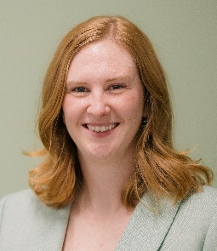
Award for Early Career Achievement in STEM
Dr. Kim Ingraham, PhD; Assistant Professor,
UW Electrical and Computer Engineering

Dr. Kim Ingraham is an Assistant Professor of Electrical & Computer Engineering at the University of Washington. She directs a research laboratory focused on intelligent assistive robotic systems that restore and enhance human mobility. Her work integrates wearable robotics, adaptive control, and clinical rehabilitation to develop personalized exoskeletons, prostheses, and powered mobility devices for individuals with neurological injuries and motor disabilities.
Dr. Ingraham’s interdisciplinary training spans biomedical engineering (BE 2012, Vanderbilt University) and mechanical engineering (MS, PhD 2021, University of Michigan). She was a CREATE (Center for Research and Education on Accessible Technology and Experiences) postdoctoral fellow in Rehabilitation Medicine at the University of Washington. Prior to beginning graduate school, she worked as a Research Engineer at the Shirley Ryan Ability Lab in Chicago.

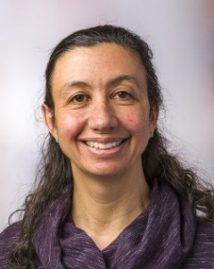
Award for Excellence in STEM Education/Outreach
Dr. Nina Salama, PhD; Senior VP for Education
Fred Hutch Cancer Center

Dr. Salama is Senior VP of Education and currently leads the Office of Education and Training at Fred Hutchinson Cancer Center where she prioritizes training and mentoring of the next scientific generation.
Dr. Salama received her BS in Honors Biology from University of Illinois Urbana-Champaign in 1989 and her PhD in Molecular and Cell Biology from University of California Berkeley in 1995. Dr. Salama became interested in the ability of pathogenic bacteria to manipulate host cells and tissues to create protected niches within the human body. Dr. Salama spearheaded the development of genetic and genomic tools and an animal model of infection for the study of Helicobacter pylori, the first bacteria to be designated as a carcinogen by the World Health Organization. In 2001 Dr. Salama was recruited to Fred Hutchinson Cancer Center as an Assistant Professor in Human Biology. Now a full professor, her work focuses on the role of genetic variation and cell morphology in chronic stomach colonization by H. pylori. She was co-Director of the Molecular and Cellular Biology Graduate Program jointly administered by UW and Fred Hutch from 2016-2022 where she developed several initiatives to promote recruitment and retention of students from backgrounds historically underrepresented in STEM with a particular focus on more equitable access and improved mentoring.

